INTERNSHIP TASK 2 REPORT

Data Analysis using Pandas

Student Details
Name: Pranav Ranjan
Internship: Python Developer Intern (Alfido Tech)
Date: 1 May 2026

1. Objective
The objective of this task is to perform data analysis using the Pandas library by loading a dataset, handling missing values, applying filtering and grouping operations, and extracting meaningful insights.

2. Tools & Technologies
- Python
- Pandas Library

3. Dataset Description
The dataset used is a CSV file (data.csv) containing the following fields:
- Name
- Age
- City
Some values in the dataset are missing and are handled during data cleaning.

4. Code Snippet

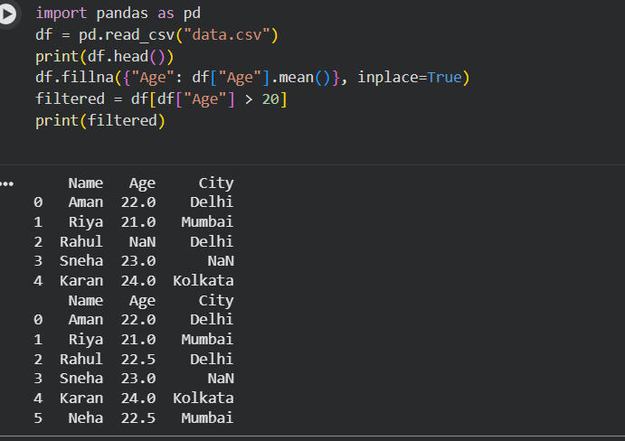

5. Code Impelmentation

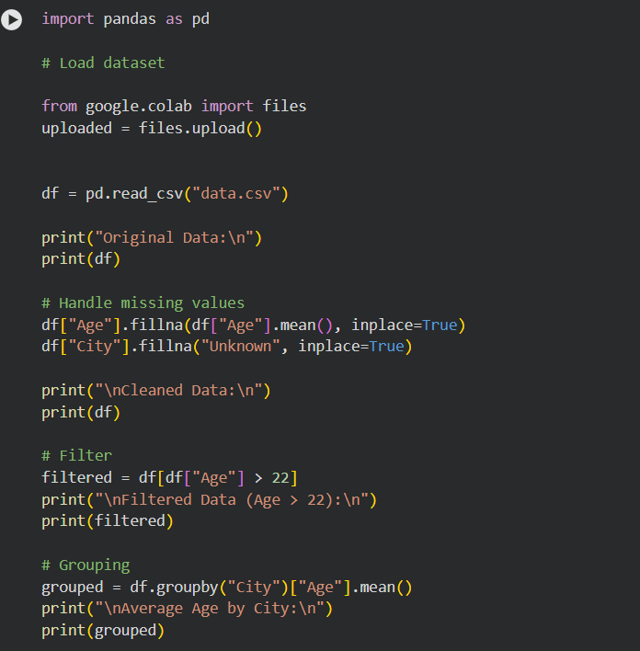

6.Output

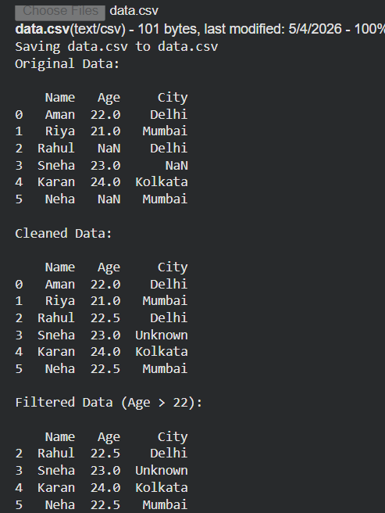

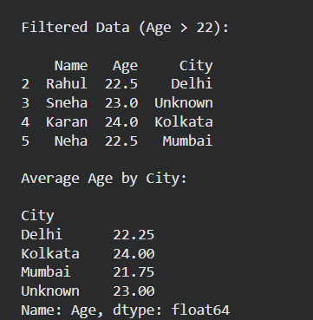

7. Insight Summary
- Missing values were handled using mean substitution and default values.
- Data cleaning improved dataset quality.
- Filtering allowed focused analysis (Age > 22).
- Grouping provided average age insights by city.

8. Links
GitHub Repository:
https://github.com/pranavyash2202-tech/Data-Analysis-Using-Pandas

9. Conclusion
This task provided practical experience in data analysis using Pandas. It helped in understanding how to clean, process, and analyze datasets efficiently.

